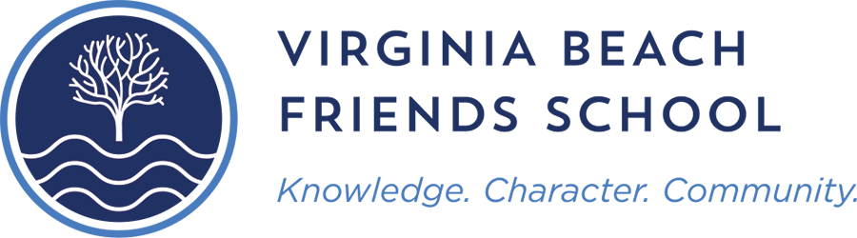

Parents and Students,

Summer is upon us and it is time for relaxing and fun in the sun! Here at VBFS we want our students to enjoy their summer vacation, but also continue to keep in place the skills they have attained this school year. Summer reading is an integral part of maintaining those skills for the upcoming school year.
Many studies have shown that students who do not read, or read infrequently, over the summer break may experience the dreaded “summer slide”- a decline in skills. In order to prevent that, it is recommended that middle school students have at least 30 minutes of reading each day. These dedicated reading times can include many different types of reading material such as newspapers, letters, online material and of course books!
Let’s help our Middle School students not become “rusty readers”, by encouraging them to complete their required summer reading before the new school year. Below is a list of local Summer Reading Program links that may be helpful and fun for the students to participate in.

Summer Reading Programs

- Virginia Beach Public Library Summer Reading Challenge
https://www.vbgov.com/government/departments/libraries/programs-classes/pages/summer-reading-challenge.aspx
- Norfolk Public Library
https://www.norfolkpubliclibrary.org
- Chesapeake Library Summer Reading Program (June 20-August 15)
https://chesapeakelibrary.org/summer
- Barnes and Noble Summer Reading Program *EARN A FREE BOOK*
https://dispatch.barnesandnoble.com/content/dam/ccr/h/summer-reading/2022/126443-06BNJournalSheetPrintable.pdf
- Books-a-Million Summer Reading Program
https://promo.booksamillion.com/SummerReadingAdventure2021.pdf?oxid=1167&oxname=summerreadinginfo&oxpage=summeradventure&oxpos=top&oxdate=050621

Thank you and have a great summer!

Courtney Grew
VBFS Librarian
CourtneyG@vbfschool.org

